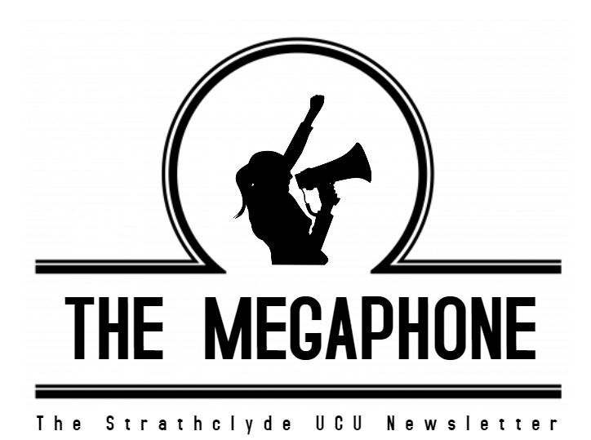
Issue 10 July 2023
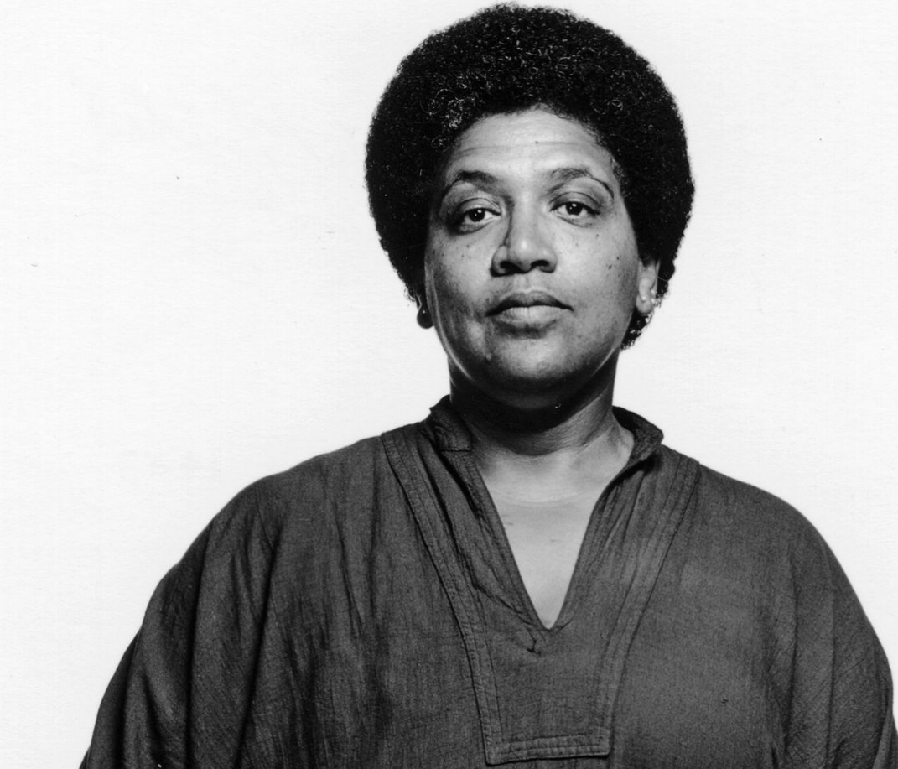
It’s possible to take that as a personal metaphor and then multiply it to a people, a race, a sex, a time. If we can keep this thing going long enough, if we can survive and teach what we know, we’ll make it.
(Audre Lorde, 1972)

Welcome to Issue 10 of The Megaphone
The Megaphone is officially 10 issues old. It’s lasted longer than many of our Prime Ministers and has been infinitely more truthful too. This edition is a bit different, featuring guest blogs, letters and messages from members, supporters and friends. We hope that it will provide some inspiration and motivation to keep fighting this fight as we enter the most crucial period of the action. For those members not taking part in the MAB your colleagues need you to offer financial support and solidarity. There are details below on how to do this; they need your help, just as you have needed their sacrifices.
At national level discussion between UCEA and UCU are ongoing, albeit our General Secretary’s email last week highlighted the continued challenges caused by UCEA’s truculence and desire to cause pain upon members. At local level your committee have been urging the university to take steps towards resolving this dispute by calling on meaningful negotiations, to address issues at a local level, and to adopt alternative approaches to deductions. We will update UCU members when we can.
We are aware that some departments have been sending emails which suggest that members need to give advance notice of taking part in the MAB. This is unequivocally not the case. If you are being pressured to do so, please contact the branch committee (ucu@strath.ac.uk) and we will raise a dispute on your behalf. We have already had reports of intimidation and pressure tactics in some places and we are currently taking action on behalf of colleagues. Senior management are getting desperate, which means that our action is working, but we must not give in to bad behaviour and unfair (and likely illegal) attempts to intimidate us into mitigating or giving up our action.
Better news has been forthcoming regarding the USS pension scheme which has again been found to be in rude health. Just as we told UUK on 1,776 occasions the scheme is healthy and there was no logical reason (other than greed) to cut our pensions or to increase our contributions. The next few months will see the fruits of our collective withdrawal of labour be borne and as a branch we must be very proud of the stance we took over the past 5 years and more. Without it we would all be considerably worse off and our retirement (whenever that is) would be far more perilous. This victory should inspire us to keep fighting the four fights; we have shown that when we unite and fight that we can win. Let’s do it again.

Yours in solidarity,
Strathclyde UCU committee.

Universities in the UK: How did we get where we are and where can we go from here?
One of our members shared their thoughts on the Four Fights and USS disputes. Interesting reading whether you are a new members or more seasoned.
It’s been a tumultuous past few years in the university sector – from the seemingly perpetual strife over pay, pensions, and working conditions to the enormous upheaval during Covid-19 - but these particular years might also be the only ones experienced by our students. Now the sector itself is under political pressure as the UK government announces a ‘crackdown’ on ‘rip-off’ degrees – language that is aimed at constructing universities as ‘the problem’ when wider economic mismanagement and declining purchasing power makes life harder for most of us. So, how did we get to this point in the UK university sector?
Several factors have been at play. The first is a long-run, and very significant, fall in funding per student from the public purse. Some, but not all, of this shortfall - which has particularly hit the Humanities - has been filled by student fees. But these fees and living costs have accelerated debt levels amongst students, where once their education would have been free and costs covered by a grant, and this fee income to universities has not been adjusted for inflation for over a decade. Other funding shortfalls have been made up by the expansion in the number of students coming from overseas – to the point where this now makes up over 20% of universities’ overall income – and through external funding, where the competition to secure awards from research councils has become ever more intensified and competitive for staff.
One immediate impact of the switch to students as paying ‘customers’ in this new world of higher education has been the perception among its leaders of the need for universities to make themselves visually attractive via changes to infrastructure – the ‘shiny new buildings’ and sports facilities which have sprung up across so many campuses. A corollary to this has been the long-run declining proportion of expenditure dedicated to staffing, through chronic wage suppression and the much greater use of precarious contracts which leave staff in perpetual uncertainty. These contracts disrupt people’s lives and wellbeing because to maintain employment often means constantly having to be on the move. Of course this precarious employment has become a feature of work more generally in society, but the personal investment in getting to the point of employability in the university job market requires years of study and mounting costs in addition to the irreplaceable expertise in the areas which staff develop. So ‘hanging in there’ despite the insecurity and uncertainty is understandable, while the expectations placed on early career staff increase year on year. We might add to this other areas of additional cost-cutting and added pressure: the move to ‘open plan’ working for staff despite a wealth of evidence that this is inimical to the kind of work universities engage in, allied to the diverse needs of an increasingly complex student body which require significantly more support and time.
On top of this, the projected pensions for staff in the USS scheme were recently cut by an average 35% despite a wholly discredited evaluation of the pension fund’s worth in 2020 – an issue about which universities leaders and their staff had good reason for finding common cause. Instead, it has had to be remedied by staff losing more pay - and students experiencing more disruption – through industrial action as the only recourse. All this while university managers sank countless millions into funding a deficit constructed to suit a wider agenda of detrimental change. Where was the leadership in universities, and acknowledgement of our common purpose, to have challenged this manufactured deficit publicly, and to have worked together for the good of the sector?
In short, universities in the UK are now businesses, but often ape the worst behaviour in the business world by simply piling more pressure on staff rather than working collegiately. This rupture has been facilitated by significant shifts in how universities are structured, with the previous decentralisation of power and decisions at faculty level now replaced by a centralisation of power and management by command. This has left staff less secure and less valued, but also less able to challenge the direction of travel because they have less voice. At the same time as this centralisation of power and decision-making there has been a ramping-up of bureaucratic external oversight: research excellence frameworks, teaching excellence frameworks, national student surveys and the omnipresent ‘ranking’ of universities by league tables – every aspect of which is conceptually flawed and a source of so much frustration for staff who can see through the way these various exercises are gamed for competitive advantage. Uniquely, the university sector has found itself simultaneously in the midst of the worst excesses of free-market competition and Soviet style bureaucracy. More recently, one of the few sensible external constraints on universities – the cap on maximum numbers in individual institutions to allow the sector to flourish across different regions – has been lifted in England, resulting in a chaotic lack of staff, facilities and student accommodation in some universities which have over-recruited and a crisis of recruitment in others, exacerbating the use of precarious contracts to meet these sudden shifts in demand. Thus the whole idea of universities as a public good, able to offer opportunities across the land, has been sundered in the name of market competition and survival of the fittest.
Within this broad framework of change it’s clear that not all universities are the same. This has been seen in the current dispute, where some institutions are not penalising staff financially for the action they have been taking, or are penalising more proportionately, while others have been deliberately and disproportionately punitive. This clash between university employers in the UK and their own staff has thus been long in the making, and in a rare moment of enlightenment the employers’ body, UCEA, recently called for a review of the funding model of the entire university sector. This is no accident, as the current dispute is the most sustained and damaging – for staff, students and the reputations of UK universities alike – ever experienced. Perhaps it is a realisation that there comes a point at which staff working in the sector can no longer be the element that constantly has to give way; if any good comes out of this current mess it might be the need to rethink the role, purpose and value of universities and those who work and study in them.
It has been a long time coming, but this does feel like a breakpoint at which – on pay, precarious contracts and sustained inequities in gender and ethnicity across the treatment of staff and their working conditions – enough is being seen as enough.
As a number of universities – most recently Queens in Belfast, Glasgow, and Newcastle – have publicly stated, there is more reason for common purpose between employers and staff in the university sector than there is for division, especially in the current climate where the university sector itself is under such threat politically. In short, it need not be this way. Perhaps now UCEA can start to see the damage of their approach and move towards some sense of common purpose. But – as with the restoration of the USS pension – there is scant evidence to suggest it will do this of its own accord and without sustained pressure. We need to remain united and to remain strong.

Why Take Part?
A question some members may have asked themselves of the past few months. Here, one member providers their answers and sets out why they are participating in the MAB.
I’ve been thinking about this a lot over the past several months. Why take on the bother, the stress, the headache? Can we really win, and what does a win look like? And even if we do win, is it really worth all this damage?
There’s something in the answer, for me, about not being bullied. It’s about not accepting this status quo of declining standards and conditions as inevitable. It’s about calling out unreasonable workloads instead of always finding a way to do a bit more. It’s about standing up for colleagues who are being buffeted around on precarious contracts. “I’m sorry this is happening to you” only goes so far.
The situations or occurrences in life that trouble me the most are the ones I feel I should have responded to differently, usually when I haven’t spoken up for myself or someone else. These are the makings of rumination and if I’m not careful, they take up residence in my head and bleed my optimism and sense of agency. I find myself thinking more negative thoughts and having more negative conversations, shoulders hunched up and head down. For me, this is what does more significant damage.
So whether or not we win, engaging in this industrial action has been about choosing dignity and action over cynicism and despair. And here’s the thing: there’s a powerful magic that gets enacted by choosing hope, by exercising agency, by connecting with others. All of a sudden, something that felt entrenched and impossible becomes doable … maybe not immediately or without sacrifice, but doable.
In standing up, I can see better. I can see it begin to take shape. As I dare to believe, I am fortified by others. As we dare and hope and act together, this powerful magic becomes more than the sum of our individual parts; it becomes a critical mass of the many taking back some of our power from the few.
So why am I taking part? It boils down to a fundamental question. What am I doing with my one wild and precious life: hunching and ducking or standing up and daring?

Why I am MABing; a letter to my students
In a similar light to the previous contribution this open letter from a member reflects on their feelings over the past few weeks when faced with the ongoing dilemma over taking action which can impact upon students’ learning. Read on to find out more.
We are weary. Exhausted. Some of us are nearing the edge of reason, ready to turn. Pressure from all sides, building inside us.
Why are we striking, I ask myself? The millionth time over. The greater good, the stats are important, the pay the conditions, they all matter.
Reality now hitting hard, my family asking if we will have enough money to see us through. A worry that for the greater good I compromise them, the people I love.
The harm caused to you, our students, too much to bear at times.
We are in this profession because we live and breathe your journey and we strive to support your success every single day. So to suddenly undermine this for our cause?
How can we sleep at night?
Is this selfish, is it worth it? So many perspectives. Our students and your parents, understandably devastated. To pause your journey for our cause. Not yours.
And yet. This is your journey. This is your cause.
Your right to a standard of excellence in education, your right to equality, your right to access the most advanced learning available. Your right to further education, to research, to grow knowledge. Your children’s rights and grandchildren.
None of this can happen without upholding the profession. To fight for what is right.
There will be sacrifice and times of hardship. There will be loss of income, beans on toast and sleepless nights for academic staff, students alike. Moments of fragility where we almost break and turn.
And yet, through this darkness there will also be strength. Relationships forged between the crusaders. Connection and love, shared humanity and a deep driving force for justice.
And when you ask why I take action that looks like harm I feel deep sorrow. I feel regret. For your current hopes and dreams. If I could change the way in which this action has played out I would, in a heartbeat.
And yet, how can I not strike when everything I believe is founded upon social justice? When I know that without this temporary pause in service, the standard of education you deserve is being torn away with casualised contracts, reduced quality measures and such high turnovers of staff?
When I know that my fellow academics from the BME community are hit the hardest with casualised pay and conditions? How do I truly stand with them as an ally if I cannot shape change? When I do not demand it?!
How do I stand for a decolonised curriculum when we don’t support the longer term employment of a diverse workforce?
When I know that without action the rights of the people to equitable standards of education will be chipped away. Privilege trumping equality.
I do not stand only for me. I stand for every academic, every student, every dreamer, every believer in themselves and even for those with no self belief.
I stand with you.
I stand for the right to true equality, the right to excellence in education and academic progression. I stand for professional quality standards.
I stand for my students from all backgrounds and my children who deserve access to the pathway to knowledge and education wherever your journey’s take you.
I do not stand against you. Even when the road is long and the path is treacherous, I stand for you.
And I stand with you.
And together we will succeed.

The Fake Dream That Strathclyde Sold Me
Just a few weeks after her own graduation, Strathclyde graduate Lucy Allan offers her thoughts on her time at the university and shares why she supports our action.
In 2018, I applied to Strathclyde University, overjoyed to be the first generation of my family to attend university. When thinking of which course I was going to take, I was sold the dream that university is all about specialising in whatever you are interested in, and that whatever subject you choose, Strathclyde would offer its best services. I applied to French and Spanish at Strathclyde University with the hope of receiving quality education and a better future. This was sadly not the case.
When I arrived in my first year, I was stunned by the student to teacher ratio (19:1), and I remember wondering how the teachers would be able to cope with so many students and so little staff. Spoiler: They weren’t. Despite being taught by a wonderful group of dedicated staff, I couldn’t help but feel the stress they were under trying to do their best under the less-than-ideal circumstances. These were not problems that the teachers kept to themselves, as the university was more than aware of the effects it was having on the department. But the university decided to ignore their struggles, and so began my first strike-affected semester at university.
Since joining Strathclyde in 2018, I have not had a single year unaffected by strikes, and I have often been standing alongside them in support. It’s not hard to empathise with teachers who are earning 25% less than they were in 2009 due to a lack of inflation-based pay rises and working with precarious contracts even after years of commitment to the institution.
I was once told that myself and my peers joining this course around the time that Strathclyde University won the TIMES University of the Year prize were way worse off than in the previous decade, with less funding and resources due to the increase of funding going to STEM subjects. Despite numbers in the Spanish department rising, the department has got smaller and smaller. In fact, the teachers are so overworked and understaffed that one staff illness led to a week of missed classes—this hardly strikes me as a University of the Year.
In a UCU survey, 4 out of 5 teachers admitted that they cannot cope with the workload. In my final year of university, the unreasonable teacher workload meant that I would be going into exams completely blind in terms of what grades I could expect, as for many classes the department were unable to dedicate sufficient time to our mock exams and give us valuable notes and feedback. During this time, Strathclyde were made aware that if they refused negotiations with the UCU, that some teachers would partake in a marking boycott, or in other terms, some students would be unable to graduate after 5 years of hard work. The University had known for years that teachers were unhappy, and they knew what would happen in June of 2023 if no negotiations were on the table. They chose to ignore this and pretend to be shocked when the worst-case scenario happened, and teachers attended the Board of Examiners with no marked exams.
What shocks me the most out of this whole situation, is that not only does Strathclyde not care about its staff, but it doesn’t care about its students either. In an email handed out to students who were unable to graduate due to the marking boycott, Strathclyde took the position of blaming the teachers, and reminded students that only a small number (7%) of students would be affected. It seems like this wou STEM departments, none of them would be affected by this boycott, and barely any are even aware of the effect it has had on the HaSS department. It was at this moment where it was solidified in my mind that Strathclyde does in fact not believe in the important of every subject and specialisation choice of students, but only the ones that economically benefit them the most.
Nearly a month after the graduation period started, I wonder when Strathclyde will address the situation and give its true condolences to students who have worked relentlessly over the past 5 years through strikes and a pandemic. I wonder when they will finally decide to negotiate with the UCU before the situation gets even worse and the university reputation breaks beyond repair. Finally, I wonder when they will stop selling the fake dream to non-STEM students that their course is valued by the university.

Student Q&A session
A number of members came forward to the committee and volunteered (more of this please) to host a Q&A session for students who – due to the vacuum created by the university – were left in limbo, in the dark and out on a limb (choose whatever metaphor you prefer). Reflecting on the experience, one member writes about what took place at the session.
As the university’s response to the MAB became clear, many of us were alarmed at the abandonment of quality assurance practices and basic academic standards for assessing students’ work. It is worth noting that this alarm was shared by those who participating in the MAB and those who were not. We were already concerned at the limited communication from university management addressed to students and their concerns about what was happening and what they could expect. Many of us were receiving emails from students that reflected their significant anxiety, not just around assessment and progression or graduation, but around being left in the dark. It felt increasingly important that the students know about what was happening.
Two meetings took place in June and both were well attended. Students were informed that:
- The normal regulatory framework which has been long established to ensure, as far as possible, high standards and fairness has been comprehensively superseded at very short notice.
- The scale of the regulatory changes amount to what we might expect in extreme, unavoidable circumstances, like a global pandemic. Indeed, in the spring of 2020, the regulatory changes were not as extreme as what we have seen this year. The changes this year, however, are in reaction to a legally undertaken, industrial dispute about working conditions.
- Employers were informed of the forthcoming MAB months ago, and yet still have refused to negotiate (since March) such that this could be avoided.
- Some boards proceeded despite protestations of external examiners or without them present
- Fewer than 120 credits were accepted for students to graduate
- Some students were going to graduate with unclassified degrees (which then did happen after these meetings)

Dissertations
- Dissertations, normally required to be marked independently by two academics, were marked in several instances by only one, often one who did not have subject expertise
- Other dissertations (sometimes within the same cohort of students) were properly marked by the students’ supervisor and a second academic
- Yet other dissertations (again, sometimes within the same cohort) were independently marked by the supervisor and another academic, but due to the start of the marking boycott, the two did not discuss their respective assessments of the work or agree a mark. We are aware that in some departments, in those situations, the higher mark was given.
- These marking discrepancies have a high potential to unfairly impact students’ degree classification.
Progression
- Some marking has not been completed
- Important quality assurance processes have not been followed, e.g. double marking and moderation
- Different “rules” have been applied to different groups of students within the same cohort when calculating class grades
- These mitigations mean that returned grades may not provide a fair or accurate reflection of students’ submitted work or attainment of learning outcomes
- There may be additional issues with regards to professional accreditation

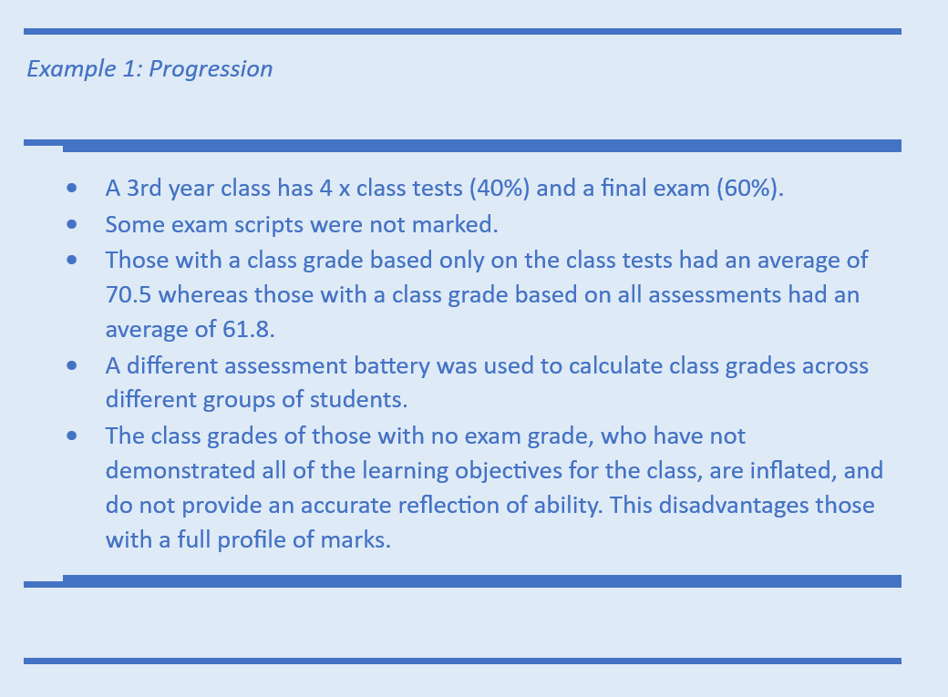

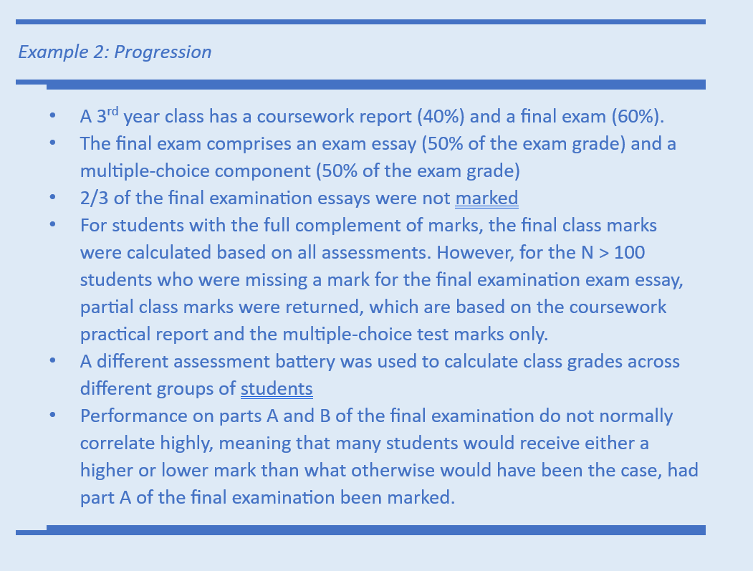

Students were rightly concerned about the likelihood that they or fellow students were being disadvantaged by these changes. We were not able to answer all of their questions. We did, however, offer some questions they might consider asking their Heads of Departments and University Management in regards to their dissertation:
- How was my dissertation marked?
- If my dissertation was doubled marked, did the two markers award the same mark?
  - If not, was I awarded the higher of the two marks?
  - If not, why was I not, when some students were?
- If my dissertation was single marked:
  - Was it marked by my supervisor?
  - If not, how can my mark be considered an accurate reflection of my work when no-one else had the knowledge of my specific project or my performance throughout the year?
  - Did the marker have expertise in the topic area?
  - If not, on what basis is the mark considered to be an accurate reflection of my work?
  - Were there students who were double marked and a mark was agreed that was higher than the mark awarded by the academic who awarded the lower mark?
  - If so, why was my dissertation not double marked when it could have led to me receiving a higher mark?

We offered these questions in regard to their progression:
- Were all assessed components marked?
- How was my module grade calculated?
- Did all students in the module have their grade calculated in the same way?
- Were appropriate quality checks conducted?
- Will unmarked work be marked? If so, when and by who?
- What will happen if I progress with unmarked work, and I subsequently fail the module (when all components are marked)?

As the fallout of the university’s abandonment of quality assurance mechanisms is slowly realised, please consider sharing these questions with students who get in touch. Make no doubt about it: UK Higher Education has tarnished the integrity of every single degree awarded this year and students deserve justice. We will continue to work with students here at Strathclyde and beyond to achieve that.

Non MABers must do their part
An action such as the MAB naturally limits who can take part and who cannot. Only those in positions including marking and assessment can MAB, and even then only if work has been scheduled for them at that stage of the academic calendar.
This means that the burden disproportionately falls on some members who will face the punitive and painful cuts imposed by our management leaders. Yet when we win, it is not just the MABers who will benefit, but all of us; including non UCU members.
So, we must all do our duty and contribute as much as we can to the Strathclyde fighting fund which in turn can be shared with those who have been at the ‘frontline’ of this dispute.
If you are in such a position then now is the time to sacrifice a portion of your salary to show your support to those who are about to have theirs slashed by 50%.
With this in mind please transfer what you can into the branch account:

UCU Strathclyde Hardship Fund 73
Account No. 20395766
Sort Code: 60-83-01

EIS CoGC dispute
Our friends and neighbours at the City of Glasgow College EIS branch have been taking strike action recently. Their committee member Dr Thora Hands - who completed her PhD here at Strathclyde - has penned this short letter to update us on their action. Please support them!
The teaching staff who are members of the EIS Further Education Lecturers Association (EIS FELA) at City of Glasgow College have just taken 5 weeks of indefinite strike action over the attempt by the college management to implement 100 compulsory redundancies. Our strike ended on 29th June as our holiday began and when we return on 14th August we will face ongoing disputes over compulsory redundancies, cuts to teaching time and courses and loss of learning support lecturers.
In the two months prior to this action the college had slayed 75 jobs through voluntary severance. Losing 175 jobs in just over two months would heavily impact the ability of our college to offer quality further and higher education courses. In particular the management have almost extinguished our learner support section made up of skilled educators who supported all of our additional needs students.
The Scottish Government Fair work Convention states that employers should give 90 days for consultation on redundancies. Management gave us 45 days and stubbornly refused to extend it to 90 days, a proposal supported by a host of MSPs.
This is what provoked the strike action.
A few days before the redundancy notices were due to be issued (two days before our holiday) they were forced to admit what the union had been telling them from day one, they couldn’t issue the notices and would have to resume after the holidays. Our strike had worked. If they had taken our advice in the first place there would have been little need for a strike at that stage.
We are continuing the fight for no redundancies. The College has an income of £99 million in public money and we are demanding that management open the books as the union believe there are other option to find the money they say that they need to save.
We fully support university staff’s action with your marking boycott and we offer all of you our solidarity.
We want to say a huge thank you to Strathclyde UCU reps Kendra Briken and Ross Gibson amongst others who have offered us unwavering support daily on out picket lines.
We are all involved in fighting to defend FE and HE education, unlike our managements who are paid eye watering amounts of money, we are the ones who are concerned about the education offered to our young people, which should be based on great teaching and not on empire building and privatisation.

Brighton Boycott
In amongst the ongoing dispute across the country, our friends in Brighton are facing a further 23 compulsory redundancies in additional to 80 voluntary redundancies that were foisted upon them. As a result, UCU has called for a national boycott of the university. This calls on UCU members to push Brighton University into resolving this by:
- not applying for any advertised jobs at Brighton
- not speaking at or organising academic or other conferences at Brighton which are outside of contract
- not accepting new invitations to give lectures at Brighton
- not accepting new positions as visiting professors or researchers at Brighton
- not accepting invitations outside of contract to write for any academic journal which is edited at or produced by Brighton
- not accepting new contracts as external examiners for taught courses at Brighton
- refusing to collaborate on new outside of contract research projects with Brighton.

Get involved! We aren’t a cult. Promise.
Many of Strathclyde UCU’s reps, committee members and activists have become involved because of periods of industrial action in the past, and we hope that this dispute too will produce a new generation of active UCU members.
YOU are the branch, and the more you can do to help, the easier it will be for all of us. As well as the current dispute, we need volunteers to support individual members with casework, to negotiate with the university, to sit on promotions appeals panels, to campaign, to analyse policy, and much else. Come along to one of our meetings, get in touch with the committee, talk to your colleagues and ask them to join us.

If everyone does a little, none of us needs to do a lot…
Speak to a committee member if you would like to get more involved, or feel free to email ucu@strath.ac.uk.

